实验五、循环与函数

1. 完成教材P45页输出九九乘法表图形
2. 实现猜数字游戏
3. 教程P75页字符串大小写转换
4. 编写如下图所示，具有能对两个操作数进行加、减、乘、除运算的简易计算器。（用函数实现）

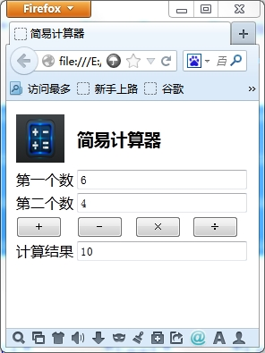

1.

代码：

<!doctype html>

<html>

<head>

<meta charset="utf-8">

<title>无标题文档</title>

</head>

<body>

<div id = "di"></div>

<script type="text/javascript">

var str="<table border='1' >";

for(var i = 1; i < 10; i++){

str += "<tr >";

for(var j = 1; j <= i; j++){

str += "<td>"+j+"\*"+i+" = "+(i\*j)+"&nbsp;</td>";

}

document.write("<br/>");

str += "</tr>";

}

str += "</table>";

document.getElementById("di").innerHTML = str;

</script>

</body>

</html>

截图：

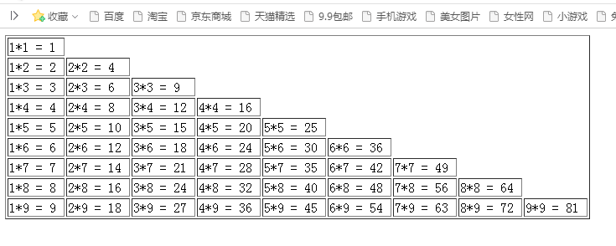

2.

代码：

<!doctype html>

<html>

<head>

<meta charset="utf-8">

<title>无标题文档</title>

<script>

var ndnum = Math.ceil(Math.random() \* 99 + 1);

var val;

var runs = true;

do{

val = prompt("请输入你猜的数(1-100)");

if(val == null || isNaN(val) || val.trim() == "" ){// val == null 放最前面

alert("请输入数字");

}else{

val = Number(val);

if(val < ndnum){

alert("小了");

}else if(val > ndnum){

alert("大了");

}else if(val == ndnum){

runs = confirm("对了，是否继续");

ndnum = Math.ceil(Math.random() \* 99 + 1);// 重新

}

}

}while(runs);

</script>

</head>

<body>

</body>

</html>

截图：

为测试显示猜的数

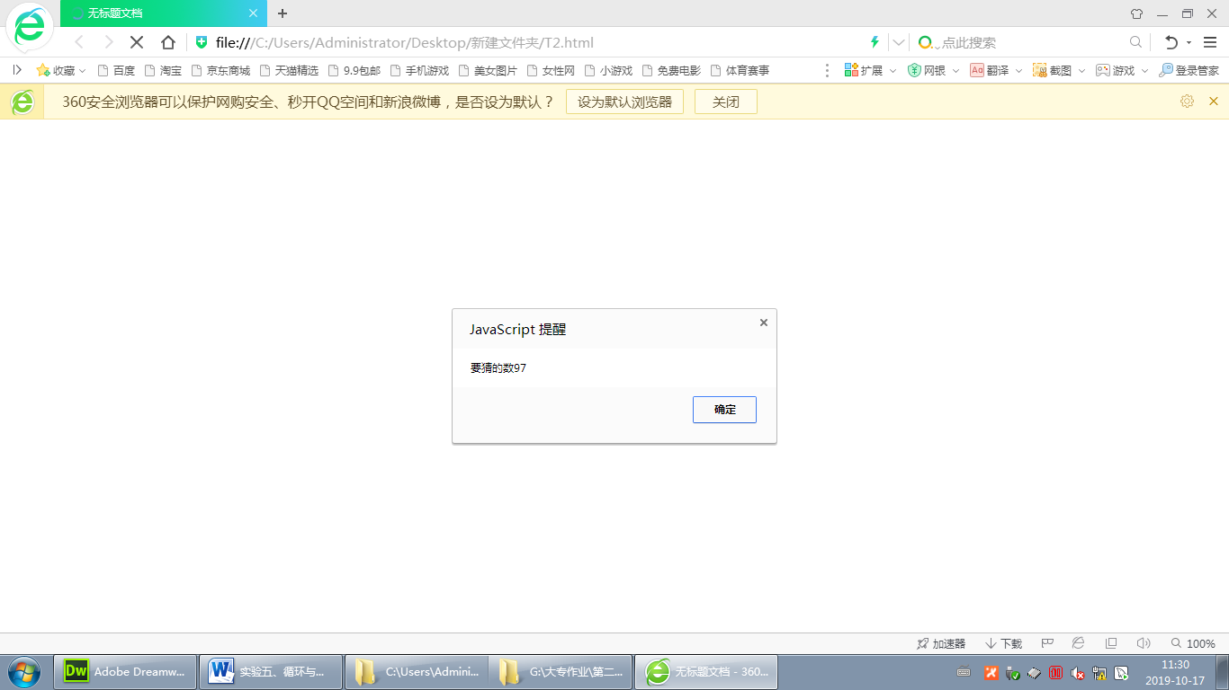

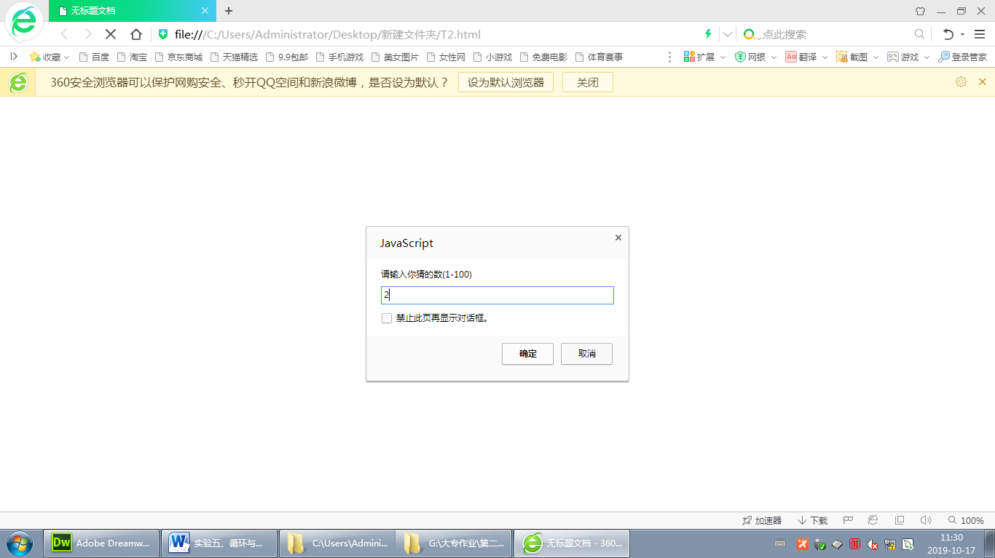

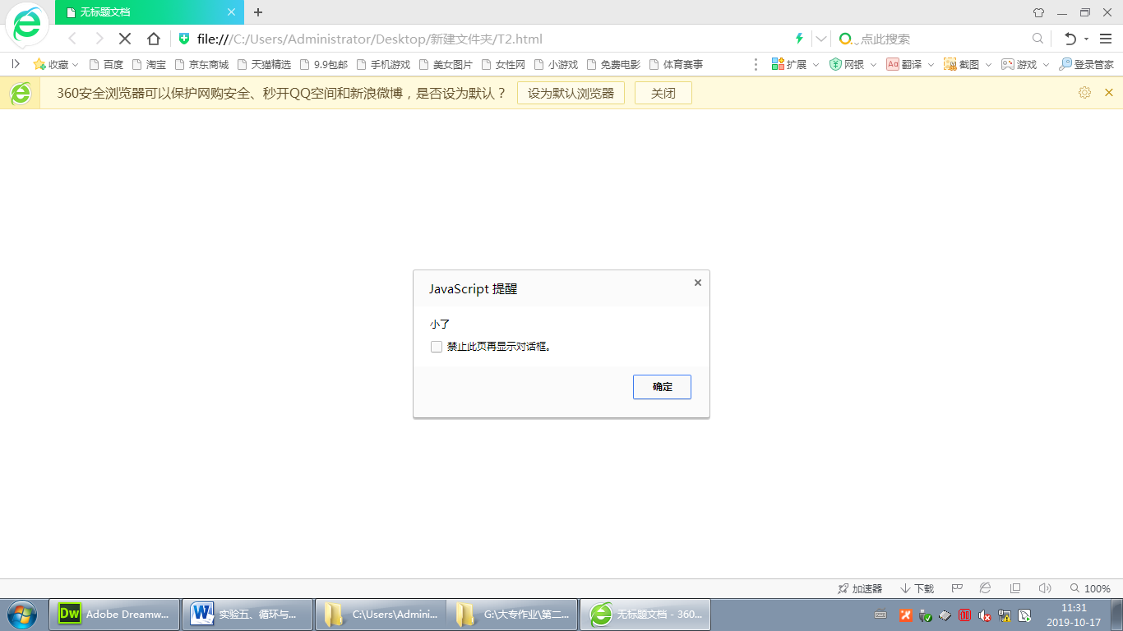

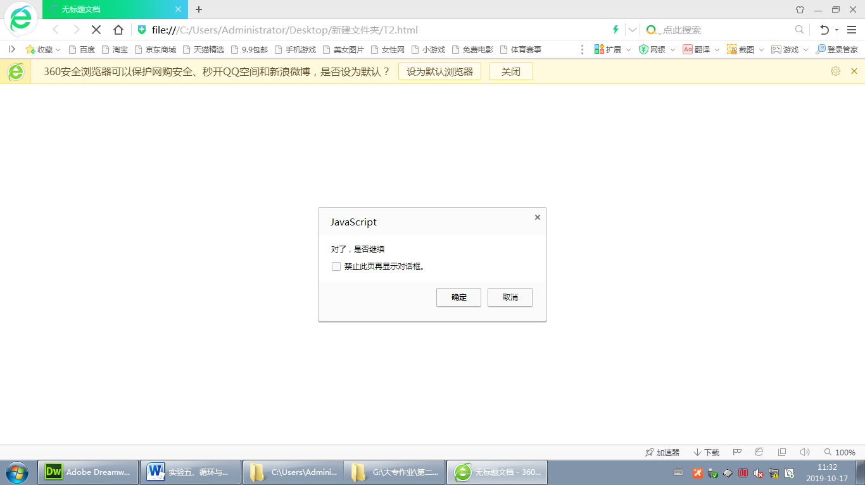

3.

代码：

<!doctype html>

<html>

<head>

<meta charset="utf-8">

<title>无标题文档</title>

<script>

function cal(tag){

var s1 = document.getElementById("tx1").value;

var s2;

switch(tag){

case 'up':

s2 = s1.toUpperCase();

break;

case 'low':

s2 = s1.toLowerCase();

break;

}

document.getElementById("tx2").value = s2;

}

</script>

</head>

<body>

<h1>转换大小写</h1>

<p>原始字母:<input type="text" id = "tx1" /></p>

<p>操作:<input type="button" value="转大写" onclick = "cal('up')" /> <input type="button" value="转小写" onclick="cal('low')"/></p>

<p>转换后:<input type="text" id = "tx2" /></p>

</body>

</html>

截图：

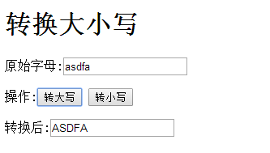

4.

代码：

<!doctype html>

<html>

<head>

<meta charset="utf-8">

<title>无标题文档</title>

<script type="text/javascript">

function cal(op){

var snum1 = document.getElementById("tx1").value;

var snum2 = document.getElementById("tx2").value;

if(isNaN(snum1) || isNaN(snum2) || snum1.trim() == "" || snum2.trim() == ""){

alert("请输入数字");

}else{

var num1 = parseInt(snum1);

var num2 = parseInt(snum2);

var fval;

switch(op){

case '+':

fval = num1 + num2;

break;

case '-':

fval = num1 - num2;

break;

case '\*':

fval = num1 \* num2;

break;

case '/':

fval = num1 / num2;

break;

}

document.getElementById("tx3").value = fval;

}

}

</script>

</head>

<body>

<h1>简易计算器</h1>

<p>第一个数<input type="text" id = "tx1" /></p>

<p>第二个数<input type="text" id = "tx2" /></p>

<p>

<input type="button" value="+" onclick="cal('+');" style="width:50px"/>

<input type="button" value="-" onclick="cal('-');" style="width:50px"/>

<input type="button" value="\*" onclick="cal('\*');" style="width:50px"/>

<input type="button" value="/" onclick="cal('/');" style="width:50px"/>

</p>

<p>计算结果<input type="text" id = "tx3" /></p>

</body>

</html>

截图：

